**Осипенко Данил, 595гр., 1 подгруппа**

1. **Answer the following questions:**
2. What is the origin of the name Scotland? – **The Scotia**
3. When was Scotland united with England? – **In the 1296.**
4. What is the location of Scotland in GB? – **The northern part of GB.**
5. What is the total area of the country? **– Its 78.800 sq.km.**
6. What is the surface of Scotland? - **The highlands**.
7. What is the number of the Scottish population? **– its over five million people**.
8. What is the capital of Scotland? – **its Edinburgh**
9. What are the main 3 areas in the country? – **the populated highlands and islands, the central lowlands and southern uplands.**
10. What is the highest point in Scotland? – **the mountain peak of Great Britain Ben Nevis.**
11. Who is the Scottish national poet? – **Robert Burns**

(0-10 баллов)

1. **Read some interesting facts about Scotland and translate them into Russian:**
2. **Eginburgh** is the capital of Scotland, but the biggest city is **Glasgow**.

**Эдинбург столица Шотландии, но самый большой город это Глазго**

1. The official flag is called the **“Saltire**”, a **white** cross on a **blue** field, representing **St. Andrew,** the country’s patron saint.

**Государственный флаг называют “Saltire”, белый крест на голубом фоне, олицетворяет святого Андрея, покровителя страны.**

1. Scottish people speak **English,** but elder people still speak **Scots Gaelic**.

**Шотландцы говорят на английском, но старики продолжают глаголить на Шотландско-гаэльском**

1. **Loch** is the Celtic name for the word “**lake**”.

**Lock это кельтское наименования “озера”.**

1. The national emblem is the **thistle,** a purple flower protected by prickles.

**Национальный символ — это чертополох, розовый цветок, защищенный колючками.**

1. Scottish biggest mystery is a **Loch Ness monster – Nessie**.

**Самый большой Шотландский миф — это озерный монстр – Несси.**

1. **Golf** is the national **sport** in Scotland. In summer you can play golf from 8 am till 10 pm.

**Гольф национальный спорт в Шотландии. Летом вы можете играть в гольф с 8 утра до 10 вечера.**

1. Men in Scotland wear special ‘skirt’ called ‘**kilt’** with the plaid pattern and they play on **bagpipes**.

Мужик в Шотландии надевает специальную юбку в клеточку называемую «кильт» и играют на волынке.

(0-8 баллов)

1. **Fill in the gaps by using the map, interesting facts and text about Scotland:**

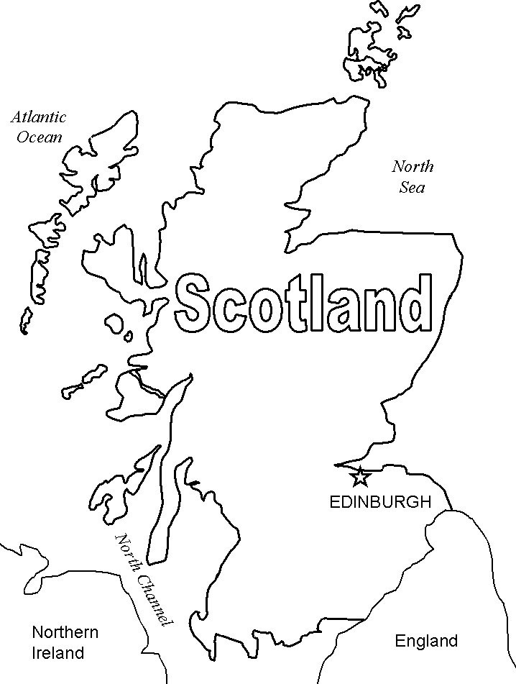

1. Scotland is surrounded by the **Atlantic** Ocean and the **North** Sea.
2. The capital of Scotland is **Edinburgh** but the biggest city is **Glasgow**.
3. **St. Andrew** is the country’s patron saint. The official flag is called the **“Saltire**”.
4. The official language is **English** but there is another officially recognized language - **Scots Gaelic**.
5. Loch is another name for a “**lake”**.
6. The most famous water monster in the Europe is **Nessie**.
7. The highest peak on the British Isles is **Great Britain Ben Nevis**.
8. Scotland is famous for its haunted **places**.
9. **Golf** is famous sport played in Scotland.
10. The Scottish national costume is called ‘**kilt’**. The **bagpipes** are Scotland’s traditional musical instrument.
11. The symbol of Scotland is a plant **thistle**.
12. **Robert Burns** is a national Scottish poet.

(0-12 баллов)

***Максимальное количество баллов – 30.***

***«Отлично» - 29-30 баллов,***

***«хорошо» - 25-28 баллов,***

***«удовлетворительно» - 16-24 баллов,***

***«неудовлетворительно» - 0- 15 баллов.***